**AIM:**

Write a C program to find Factorial of a given number without using Recursion

**ALGORITHM**

• **Start**

• Read the number n.

• If n < 0, print *“Factorial not possible”* and **Stop**.

• Initialize a variable fact = 1.

• For i = 1 to n, do:

* fact = fact * i

• Print fact.

• **Stop**

**CODE**

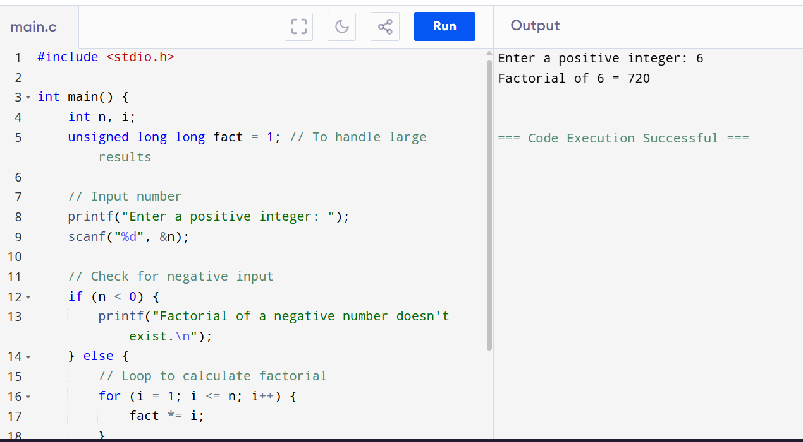

**OUTPUT**

Enter a positive integer: 6

Factorial of 6 = 720